Exercise 4

(Design the cyclic counter using D or JK flip-flops, which counts clock pulses modulo 4)

**State Diagram:**

First, we make a diagram for the clock pulses to get a better understanding to create our state transition table

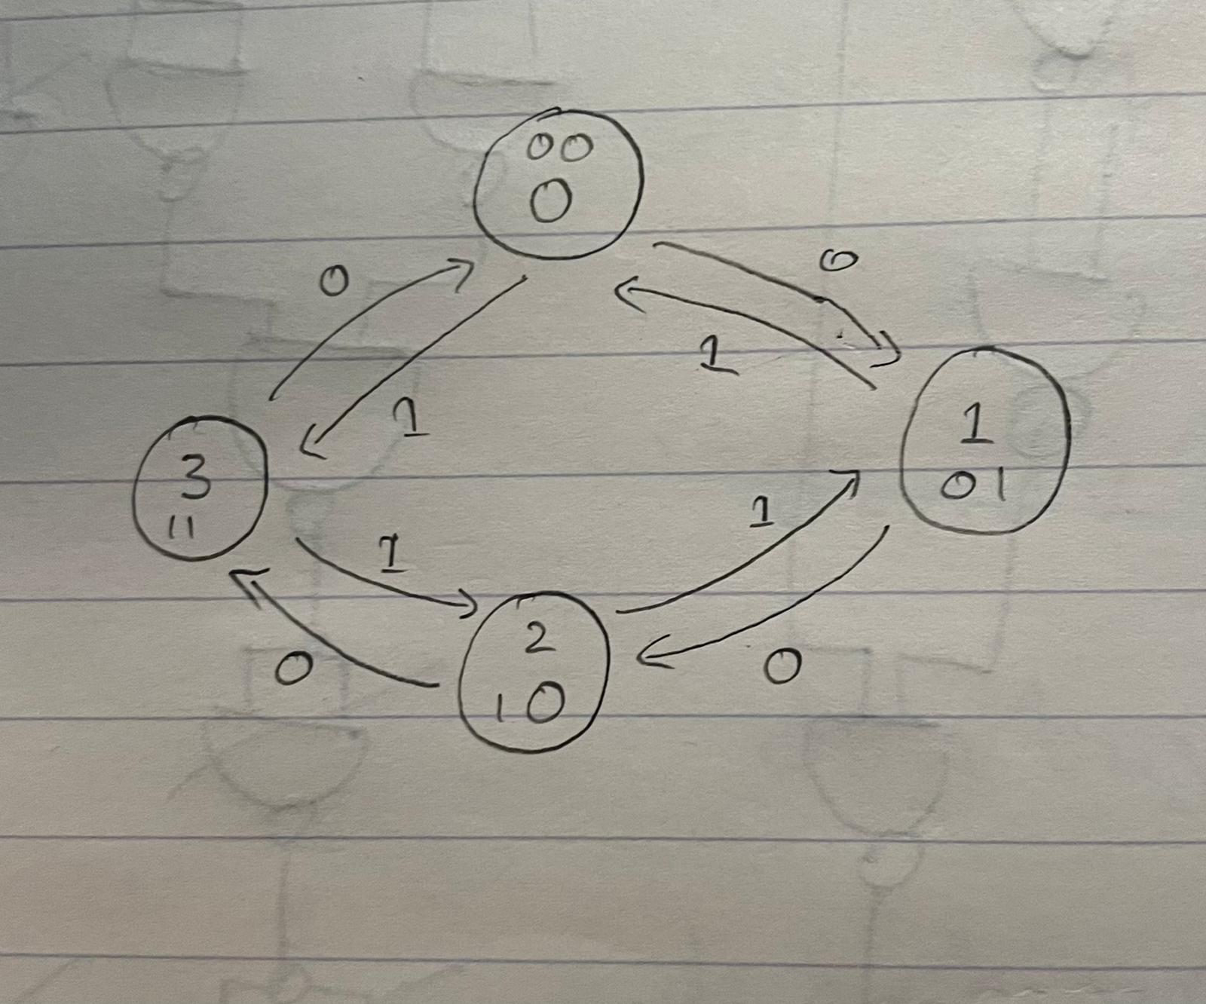

**State Transition Table:**

Now we make state transition table to find D1 and D2

|  |  |  |  |  |  |
| --- | --- | --- | --- | --- | --- |
| Sates | INPUT | Present  State | Next  State | D1 | D2 |
| 0 | 0 | 00 | 01 | 0 | 1 |
| 1 | 0 | 01 | 10 | 1 | 0 |
| 2 | 0 | 10 | 11 | 1 | 1 |
| 3 | 0 | 11 | 00 | 0 | 0 |
| 0 | 1 | 00 | 11 | 1 | 1 |
| 1 | 1 | 01 | 10 | 1 | 0 |
| 2 | 1 | 10 | 01 | 0 | 1 |
| 3 | 1 | 11 | 00 | 0 | 0 |

**Karnaugh Map:**

Now we make the Karnaugh Map for D1 and D2 to find the functions to make our circuit.

|  |  |  |  |  |  |
| --- | --- | --- | --- | --- | --- |
| ***BC*** | | | | | |
| I |  | ***00*** | ***01*** | ***11*** | ***10*** |
| ***0*** | 0 | 1 | 0 | 1 |
| ***1*** | 1 | 1 | 0 | 0 |

D1= ~bc + ~ab~c + a~b

|  |  |  |  |  |  |
| --- | --- | --- | --- | --- | --- |
| ***BC*** | | | | | |
| I |  | ***00*** | ***01*** | ***11*** | ***10*** |
| ***0*** | 1 | 0 | 0 | 1 |
| ***1*** | 1 | 0 | 0 | 1 |

D2 = ~c

**Circuit (OR, AND, D-Flip flops):**

By using the function we can now create the circuit where its accurate to our table values.

**Conclusion:**

Asynchronous counter that can store data and count up or down based on input using either D flip-flops or J-K flip-flops in this project. When the input x = 1, the counter will count up: 0, 1, 2, 3, 0, 1, 2, 3,..., and when the input x = 0, the counter will count down: 0, 1, 2, 3, 0, 1, 2, 3,...

As a result, the flip-flop can count pulses and synchronize variable-timed input signals with a fundamental reference signal [1].